MUTEC MC-3+ Smart Clock USB now approved as Roon Tested device

Berlin, April 2019. MUTEC GmbH, manufacturer of professional and audiophile consumer audio equipment, is proud to announce that the MC-3+ Smart Clock USB Re-Clocker and USB audio interface is now officially approved as a Roon Tested device. This certification program ensures a consistently enjoyable listening experience with the popular music playback software Roon.

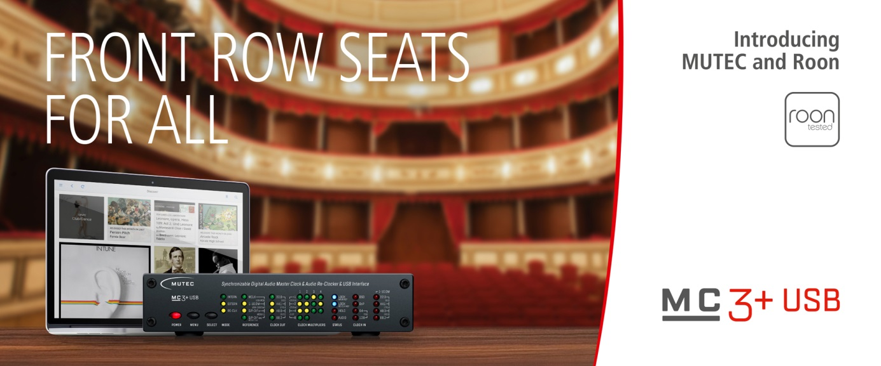

Key takeaways of this press release:
- The MC-3+ Smart Clock USB is now a certified Roon Tested device
- The certification underlines MUTEC’s commitment to high-end computer audio
- Visitors to the MUTEC booth at the upcoming High End Show in Munich can win a MC-3+USB & REF 10
- MUTEC will also be offering 30-day trial vouchers for Roon at booth F01 in hall 2.

Background
The MUTEC MC-3+ Smart Clock USB is an exceptional Audio Re-Clocker, audiophile USB Interface & lowest Jitter Master Clock. Ever since its launch, the MC-3+USB has garnered praise by owners and critics alike. Last year, the device was awarded by the editors of Fidelity Magazine, Germany’s premier audiophile magazine. Their newly created Fidelity Award highlights those audiophile products that stand out because of their technical excellence, the ingenuity of the developers, or the high-flying sonic qualities.

The MC-3+USB and Roon
Now, the MC-3+USB provides an even more enjoyable user experience in combination with the Roon player. Roon was designed to transform the experience of browsing music. Artist photos, credits, bios, reviews, lyrics, tour dates, and composers are located automatically, then interconnected by links to build a surfable, searchable digital magazine about the customer’s music collection. Roon also finds all the same links between a customer’s personal files and the millions of tracks available on TIDAL, so he or she can start with the music already in the library, then explore and discover new music from the world beyond the existing collection.

Apart from the user experience, Roon is also known to provide a wide range of software settings to ensure the highest quality audiophile playback and multi-room network configurations.

About the Roon Tested Program
Roon’s fundamental goal is to provide a consistently stellar user experience. This goal doesn’t stop at the software... the experience extends all the way down to the audio playback hardware, regardless of manufacturer. Roon currently works closely with more than 100 manufacturers through the Roon Ready and Roon Tested partner programs.

As a Roon Tested partner, MUTEC has provided equipment to Roon for testing with a variety of different operating systems and computers, and shared information about its design and capabilities. We have a direct relationship with Roon and in many cases, the Roon support team has our devices on hand, so you can confidently choose to use MUTEC hardware with Roon.

MUTEC and Roon at High End 2019
At this year’s High End Show in Munich coming up in May, visitors to the MUTEC booth will have the chance to experience an audiophile playback system consisting of Roon and the MC-3+USB first hand. As a special treat, MUTEC will be giving away one set of the award-winning Tower of Power, the combination of a MC-3+USB and a REF 10 Reference Master Clock after show. This pairing provides exceptional clocking and sound quality performance for any digital audio setup. In addition to this grand prize, MUTEC will be offering exclusive 30-day trial vouchers for Roon to all booth visitors. These will be available on a first come, first served bases. Terms and conditions apply.

MUTEC will be exhibiting at High End 2019 in hall 2, booth F01.

Presse-Kontakt:
MUTEC GmbH, Press Department
Email press@mutec-net.com
Web www.mutec-net.com
Phone 0049-30-746880-0

Picture assests:
https://www.dropbox.com/s/oyl63qqjlmamg1j/Banner_roontested_FB_1920x800_E.jpg?dl=0

About MUTEC
MUTEC is a leading manufacturer of high-quality A/V master clocks, audio re-clockers, interfaces, format converters, and signal distributors for professional and audiophile consumer audio applications. Focusing on improving digital audio reproduction and transmission processes, MUTEC’s 1G-Clock Technology raises the bar for ultra-low jitter clock generation industry-wide to an unparalleled level of performance. Based in Berlin, Germany, MUTEC is dedicated to setting new standards in sound quality, clock generation and digital audio signal processing, enabling customers to realize their visions of the perfect sound in their environments.

MUTEC products are installed in leading-edge broadcast and television stations, well-respected recording and mastering studios as well as renowned musical theatres, opera houses and universities all over the world. The new line of audiophile consumer products takes our experience from the broadcast and pro audio world into the listening room at home to provide an unprecedented music experience.

